

USING THE CFC BEEF FEEDER GROWOUT MODEL

The CFC Beef Feeder Growout Model allows you to define and simulate a complete growout model. All predictive equations, multiplier defaults, and adjustment factor defaults are from the NRC Nutrient Requirements of Beef Cattle, Seventh Revised Edition, 1996, with NRC 2000 modifications.

The model’s straightforward design and total flexibility allows you to define:

* the desired energy multipliers and dry matter adjustment factors for their respective predictive equations;
* the rations to be used and how they will be fed in the model;
* herd data;
* monetary data.

The growout is then simulated and provides summaries for performance, economics, total ration usage, and the growout detail for every day the animals are on feed.

The beef system is linked to the Concept5 formulation system to allow any stored ration within Concept5 to be used in the model.

The following pages will guide you through the set up and computation of the model, and will provide a description of the solution summary.

From the menu bar on the Concept5 main menu, select Tools, then Beef Growout Model.

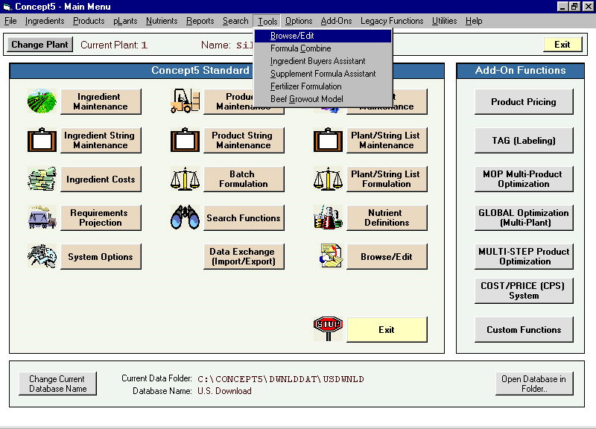

The main menu of the Beef Growout Model will open. Select the Growout Set-

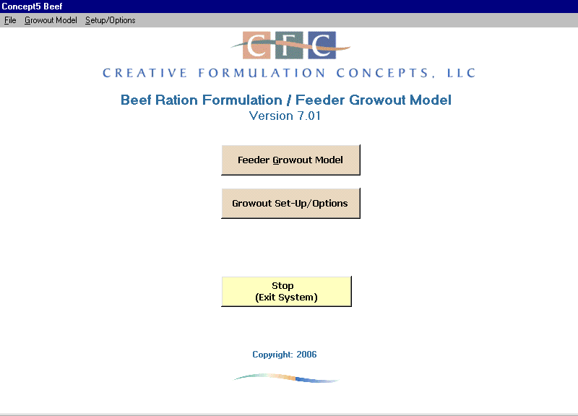

Up/Options button.

The General tab of the CFC Feeder Growout Options screen shows several frames. The Your Company Identification allows you to enter your company name and address as you would like it to appear on report headers.

The Printed Report Options frame offers several choices for the header print on all printed reports – make the desired selections.

The Concept5 Nutrient Cross Reference frame links the energy nutrient numbers used in Concept5 to the Beef Model system. Enter the nutrient number and units for both NEm and NEg from Concept5 in the boxes shown.

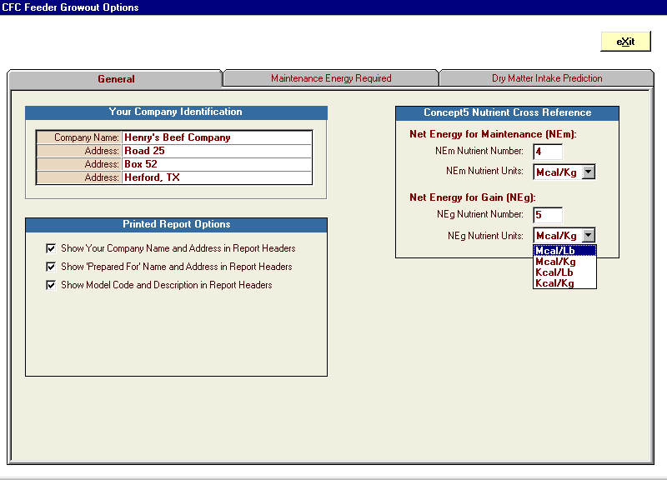

The Maintenance Energy Required tab shows the NRC predictive equation for NEm and all the multiplier defaults per the NRC.

Any multiplier default can be edited by selecting the appropriate textbox or cell and

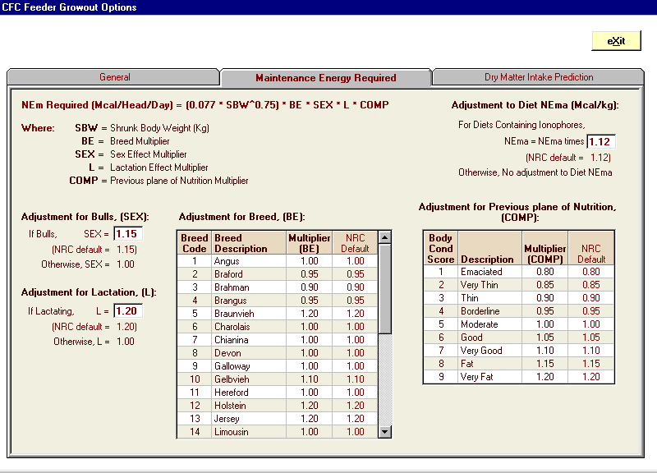

typing in the desired numbers.

The Dry Matter Intake Prediction tab shows the NRC predictive equations for DMI for Growing Calves, Growing Yearlings, and Nonpregnant Beef Cows together with their adjustment factors.

The adjustment factor NRC defaults are shown and, again, these can be edited by selecting a textbox or cell and typing in the desired numbers.

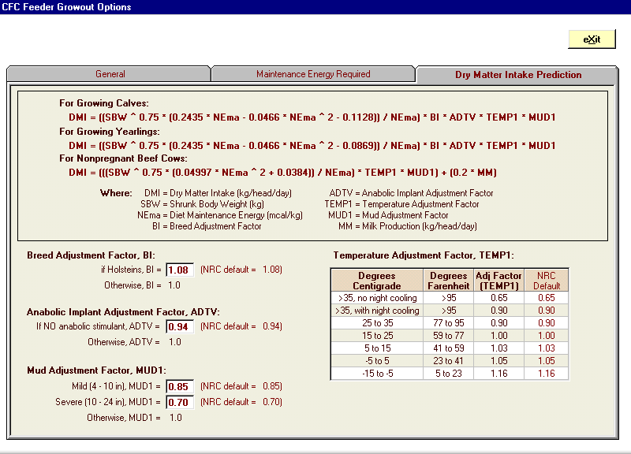

Click the Exit button to return to the main menu.

Having established your system options, you are now ready to build a model. To begin, click the Feeder Growout Model button.

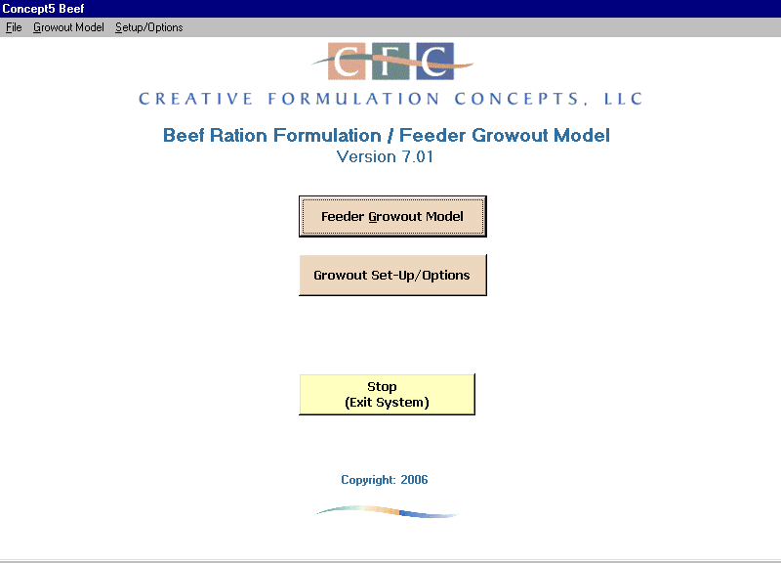

The screen header displays several buttons (some buttons are shown only when a computed model is on screen):

* The Change Plant button allows you to switch to the desired plant within Concept5.
* The Get Stored Model button opens the index of all saved models in the Beef system for easy recall. The system will store up to 1000 separate models.
* The Add New Model button will clear all entries on all tabs to begin a fresh model.
* The Save This Model button will save the model shown for later recall. And will save any changes made to an existing model (shown only when a model code i.
* The Delete This Model deletes the model shown on screen.
* The Compute Growout button computes the model and creates the solution summaries.
* The Print Reports button opens an index of the report options available for the solution.

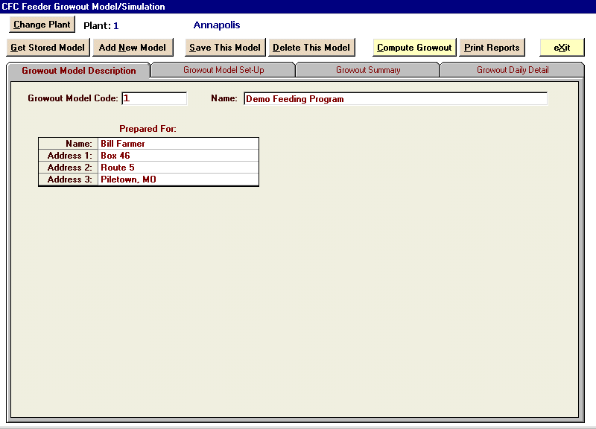

When the Feeder Growout Model button on the main menu is selected, the screen shown below will appear. On the Growout Model Description tab, enter a model code and name and, optionally, the name and address of the recipient. The code maximum is eight alphanumeric digits; the name max is 40 characters. The recipient name will appear on all reports for this model.

If you want to edit an existing model, click the Get Stored Model button and choose from the index.

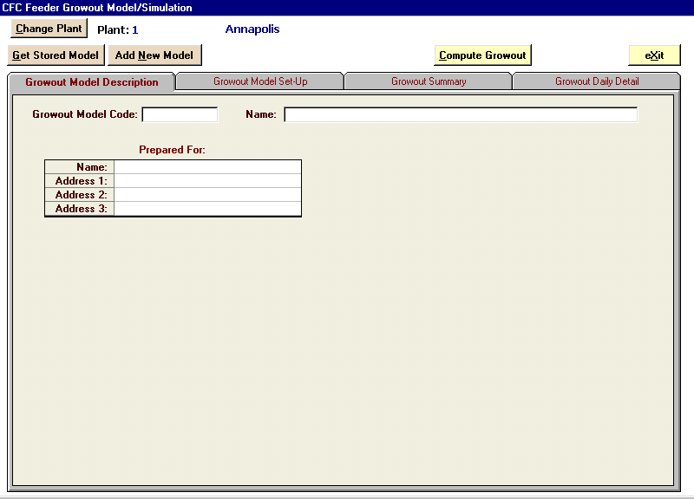

The Growout Model Set-Up tab contains all the data that will be used when the model is computed.

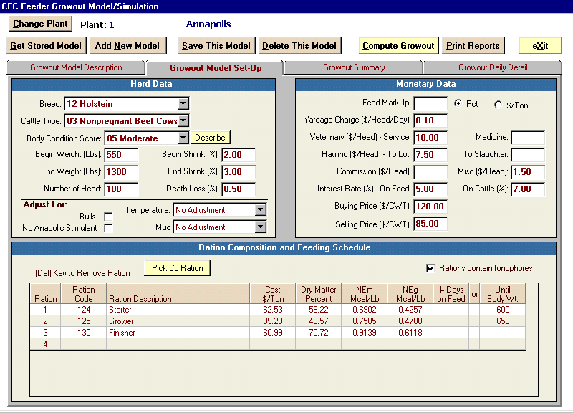

In the Herd Data frame, enter the desired information in the textboxes using the scrollbar or typing in the data. Begin Shrink, End Shrink, and Death Loss are optional entries.

Additional optional entries allow you to adjust for Bulls, Anabolic Stimulant, Temperature, and /or Mud. Begin Weight, End Weight, and Number of Head are required.

The Monetary Data frame allows you to account for all extra costs associated with the model. Only the Buying Price and Selling Price require an entry.

* Feed MarkUp: you may enter an additional markup to the feed costs entered in the Cost column of the Ration Composition and Feeding Schedule shown at the bottom of the screen.
* Yardage Costs are entered as $/Head/Day
* Veterinary Costs: costs can be separated as Service and as Medicine.
* Hauling as $/Head: you can separate the costs to the Lot and/or to Slaughter.
* Commission and Miscellaneous charges can be listed as $/Head.
* Interest Rate can be applied On Feed and /or on Cattle. The percentage entered in the textbox is an APR. The total interest dollar amount used in the summary calculation is based on the days in the growout period.
* Buying Price as $/CWT – this is a required entry.
* Selling Price as $/CWT – this is a required entry.

The Ration Composition and Feeding Schedule frame is where you specify the rations to be used in the model. They may be chosen from the existing Concept5 rations by clicking the Pick C5 Ration button and choosing from the index (click in the Ration Code cell to make the button appear).. You may also define the rations on each row by entering a Code, Description, Cost, Dry Matter Percent, NEm, and NEg. All except the last ration specified for use must also show a value in either the #Days on Feed column, or the Until Body Wt column. The Until Body Weight column designates the animal weight at which the ration will no longer be fed. You may combine both types of rations in the same model. Up to 20 rations can be used for each model.

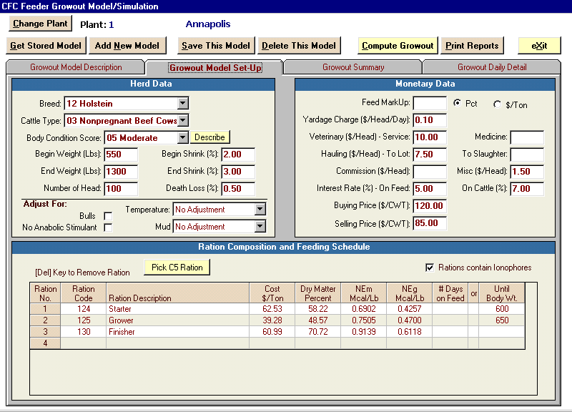

After all the desired data has been entered, click the Compute Growout button to simulate the model.

The model will compute and the screen will open to the Performance/Economic Summary tab of the Growout Summary tab.

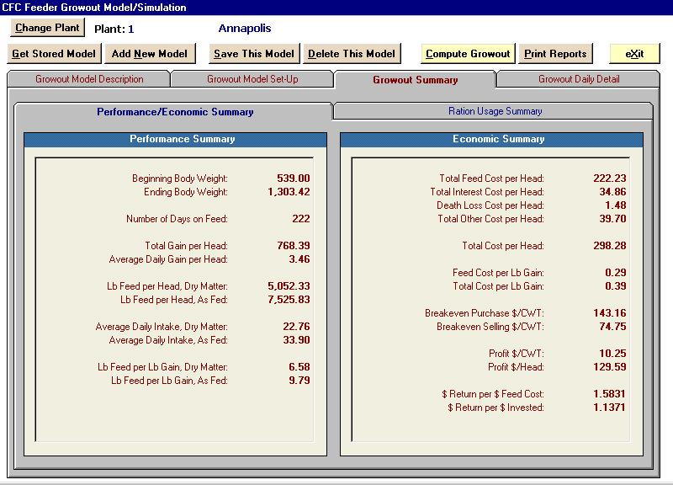

The Performance Summary is shown in the frame on the left. Starting with the beginning weight (with any specified shrink) and the ending weight (without any specified shrink), all the pertinent performance pieces of the model are listed.

The Economic Summary is shown in the frame on the right.

The Profit $/Head is calculated as follows:

1. The ending weight, minus shrink, is multiplied by the Sell Price.
2. The beginning weight, minus shrink, is multiplied by the Buying Price. To this number the Total Cost Per Head is added.
3. Subtract 2) from 1) to get Profit $/Head.

The Breakeven Selling $/CWT is calculated as follows:

The beginning weight (as CWT), minus shrink, is multiplied by the buying price (per CWT). To this number the Total Cost Per Head is added. Divide this sum by the ending weight (as CWT), minus shrink, to get the Breakeven Selling $/CWT.

The Breakeven Purchase $/CWT is calculated as follows:

The ending weight (as CWT), minus shrink, is multiplied by the selling price (per CWT). From this number the Total Cost Per Head is subtracted. Divide this sum by the beginning weight (as CWT), minus shrink, to get the Breakeven Purchase

$/CWT.

The $Return per $ Feed Cost is calculated as: [(Profit $/Head)/(Total Feed Cost per Head)] + 1.

The $Return per $ Invested is calculated as: [(Profit $/Head)/(Total Cost)] + 1. Total Cost in this calculation includes the purchase costs plus the Total Cost per Head.



The Ration Usage Summary tab shows the schedule for the entire feeding period by individual ration.

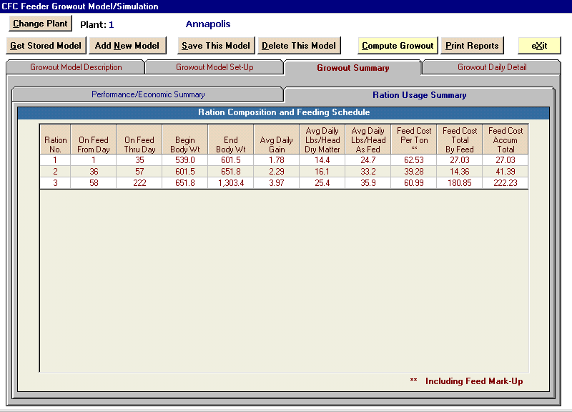

The Growout Daily Detail tab shows the feeding results for each day of the feeding period. Guided by the predictive equations, the necessary feed intake, NEm, and NEg are all listed on a daily basis.

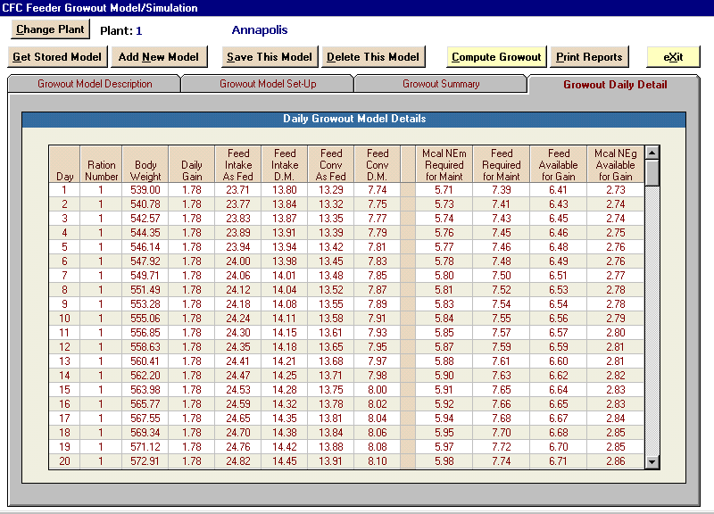

The model can be saved by clicking the Save This Model button, and recalled by clicking the Get Stored Model button and choosing from the index. Recalled models can be edited and saved again by clicking the Save This Model button.

Click the Print Reports button to open the reports menu (see following page).

Selecting the Print Reports button opens the Printed Report Options popup. Choose any option to open a soft print of the report. Shown is the top portion of the Performance and Financial Summary.

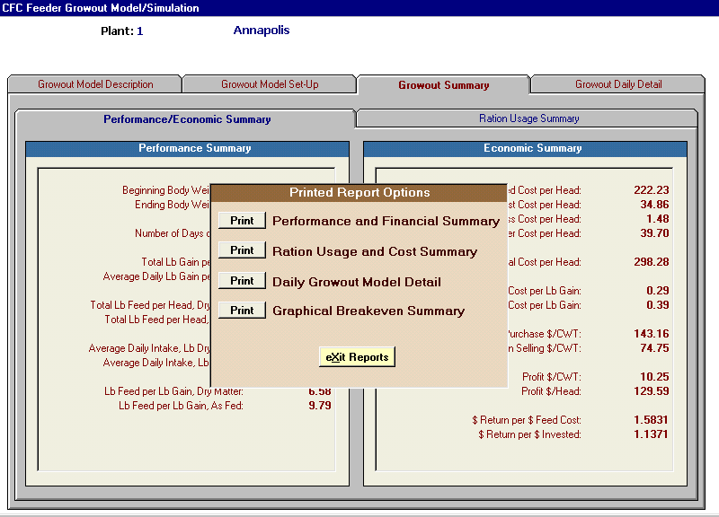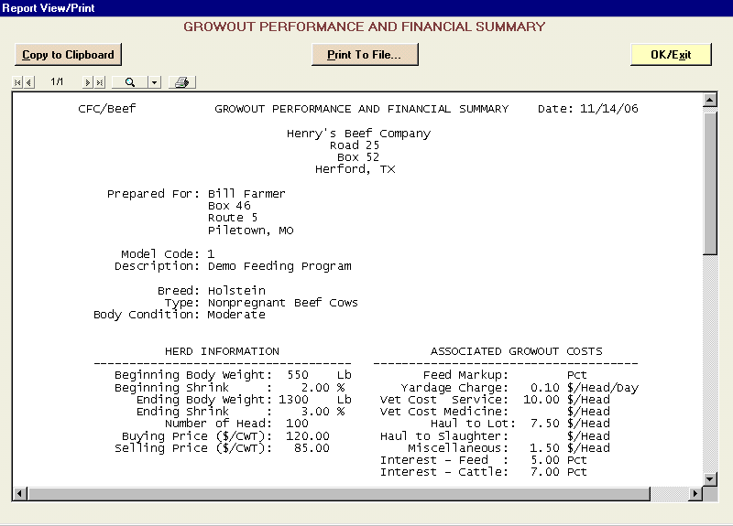



Click the Printer icon to execute a print. Or choose the Print to File button (to store as a

.txt file), or the Copy To Clipboard button for subsequent pasting into the desired application.

One of the report choices is the Graphical Breakeven Summary. This report analyzes the data input at various sell prices and purchase (buy) costs, and graphs the results for easy interpretation. The report is shown below.

